**REPORT**

|  |
| --- |
| **Experiment 1:** **Sampling and aliasing** |

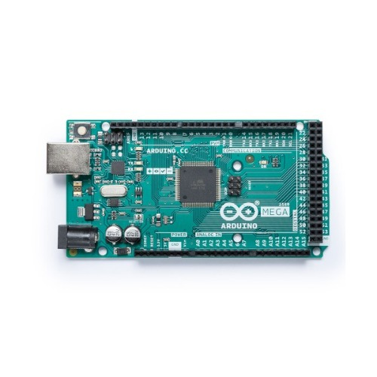

F.G.

A0

GND

|  |  |  |
| --- | --- | --- |
|  | **wave frequency** (normal) | **wave frequency** (aliasing) |
| **Theoretical Result** | **5Hz** |  |
| **Experiment Result** | **5Hz** | **3.2Hz** |

1. Result of the code plot(1pic):

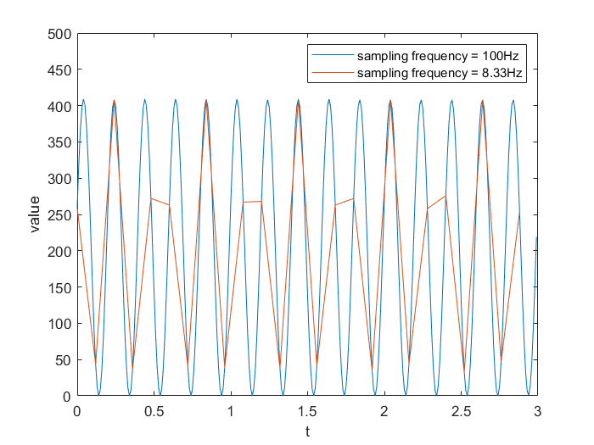

1. Result of the FFT plot(2pic):

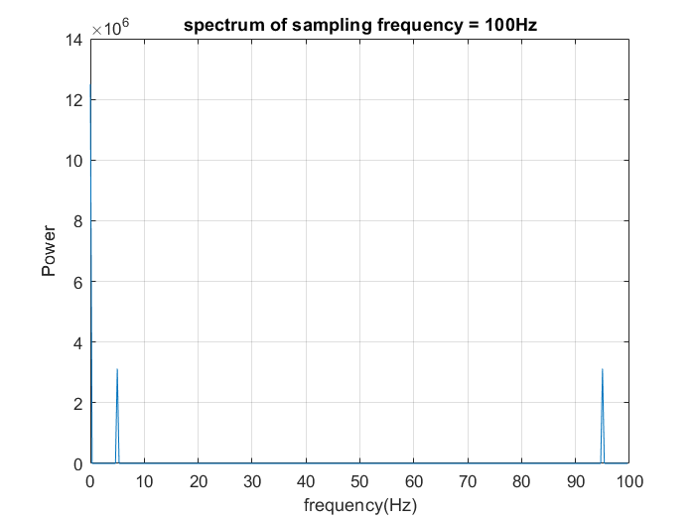

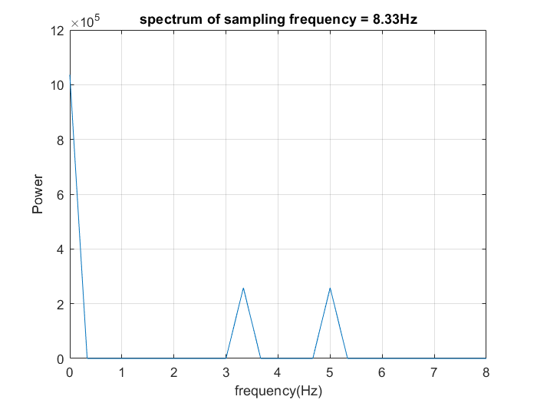

**Discuss:**

Try to explain if aliasing happened, What's bothering you?

It can cause different signals to become indistinguishable.

|  |
| --- |
| **Experiment 2: Quantization error** |

|  |  |  |
| --- | --- | --- |
|  | **Max** **error** | **Standard deviation** |
| **Theoretical Result** | **<0.5** |  |
| **Experiment Result(F.G)** | **0.3** | **0.21** |
| **Experiment Result(Arduino)** | **0.43** | **0.25** |

1. Result of the code plot(2 pics):

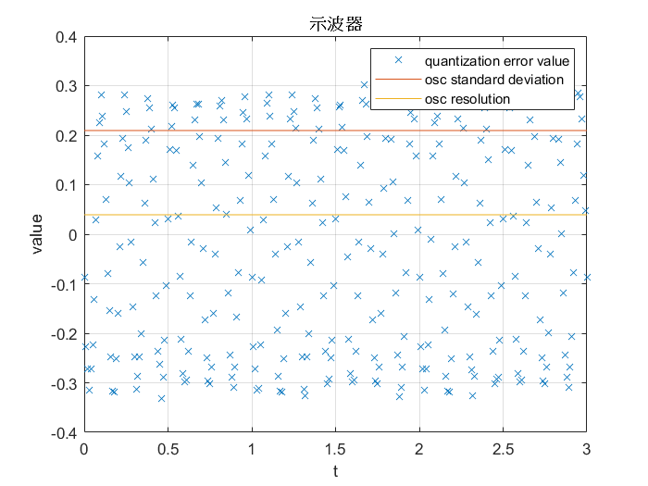

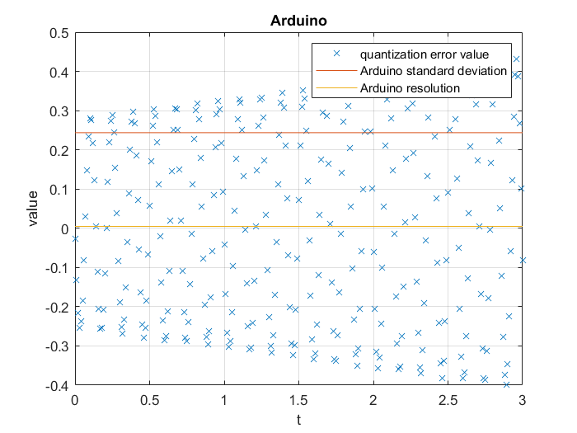

**Discuss:**

Is it what you want to get of this experiment result? Try to explain why we can not get the precise quantization error?

Yes, if you see closely, you may observe a saw-like wave shown as the figure below.

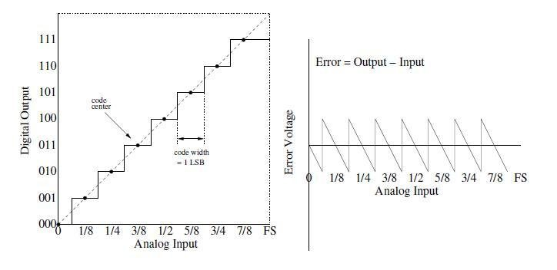

The quantization error can be affected by other factors such as noise, interference, or nonlinearities in the system, which can further contribute to the overall error in the quantized signal. These factors may also be difficult to precisely quantify and may vary over time or with different signals.